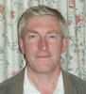
Henry Clark (Chairman) 2 Chestnut Close Tel: 01733 253203
Representative on CAPALC, Neighbourhood Planning Group, Northern Footpath Forum and Peterborough
Parish Liaison Committee
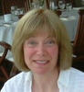
Sally-Ann Jackson 1 St Pegas Road Tel: 01733 253483
Vice-Chair, Chair of Neighbourhood Planning Group, representative on Northern Footpath Forum
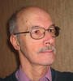
Roy Pettitt 3 St Pegas Road Tel: 01733 252049
Representative on Planning Users Forum and Village Hall Committee

Gary Wright 36 St Pegas Road Tel: 01733 252268

Emma Crowson 36a St Pegas Road Tel: 01733 252200
Representative for media/publicity and representative on Neighbourhood Planning Group

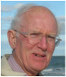
Greg Prior 1 Rectory Lane Tel: 01733 252764

David Fovargue 31b St Pegas Road Tel: 01733 254227

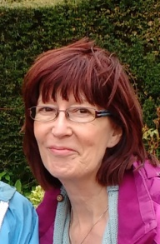 Angela Hankins (Clerk) 8 The Park Tel: 01733 253397

