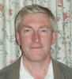
Henry Clark (Chairman) 2 Chestnut Close Tel: 01733 253203
Representative on CAPALC, deputy representative on Northern Footpath Forum and Peterborough Parish Liaison Committee
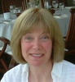
Sally-Ann Jackson 1 St Pegas Road Tel: 01733 253483
Vice-Chair, representative on Northern Footpath Forum
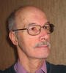
Roy Pettitt 3 St Pegas Road Tel: 01733 252049
Representative on Planning Users Forum and Village Hall Committee

Gary Wright 36 St Pegas Road Tel: 01733 252268

Emma Crowson 36a St Pegas Road Tel: 01733 252200
Representative for media/publicity

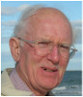
Greg Prior 1 Rectory Lane Tel: 01733 252764

David Fovargue 31b St Pegas Road Tel: 01733 254227
Deputy representative on Village Hall Committee

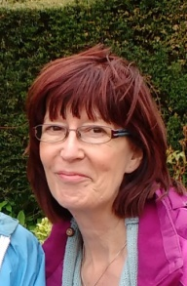 Angela Hankins 8 The Park Tel: 01733 253397
Clerk and Responsible Financial Officer

