PEAKIRK PARISH COUNCIL

Clerk: Mrs A Hankins
8 The Park
Peakirk
Peterborough
PE6 7NG
Tel: (01733) 253397

There will be a meeting of Peakirk Parish Council on Wednesday 2nd June 2021, in the Village Hall, starting at 7.30pm.
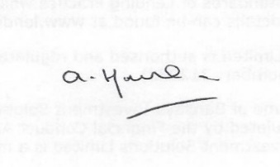
A Hankins
Clerk to the Council
Date: 27th May 2021

AGENDA

20. To note apologies.

21. To approve the execution of the lease of land from Mrs Acker for allotment use.

22. To agree the authorised signatories and account access for the Unity Trust banking application and approve an amount to be transferred from the existing Barclays Account as an initial deposit.

23. 21/00691/HHFUL – to consider application for two-storey side and single storey rear extension at 10 Firdale Close.

24. To confirm next meeting as 21st June.

