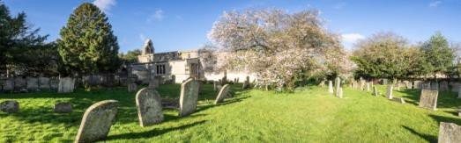

ST. PEGA’S CHURCH PEAKIRK
JUNE 2026 NEWSLETTER
CHURCH SERVICES FOR ST PEGA’S CHURCH

Sunday 7th June 10.30am – Sung Holy Communion Led by Rev’d Keir
Sunday 14th June 9.00am – Family Worship Led by Reader Derek
Sunday 21st June 6 pm – Evensong Led by Reader Derek


MESSY CHURCH – Sunday 7th June - 3pm – 4.30pm. The theme is “God’s Acre” You are welcome to join Messy Church at Peakirk Village Hall. Families of all ages welcome.


TUESDAY@10 – Tuesday 9th June 10am-12pm- in Peakirk Village Hall. Join us for coffee, scones, and chat. All welcome. Toys, books, and games are available for younger visitors.


MOBILE LIBRARY VISIT – Thursday 25th June 12 noon to 12.30pm outside the village hall. Please come along and try out our mobile library – you are also able to order books from there.


BENEFICE@THE BOOZER – Friday 26th June from 8pm onwards, meeting at The Bluebell, Glinton All Welcome

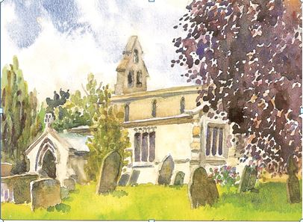
ST PEGA’S CHURCH 100 CLUB Many people in Peakirk have regularly supported the 100 Club in the last cycle of four draws. Thank you for your support. Congratulations if you were one of the lucky winners and commiserations if you weren’t successful – but I hope that you enjoyed being ‘almost a winner’ and supporting St Pega’s Church at the same time. A total of £550.80 has been paid out in prize money and £673.20 raised for the work of St Pega’s church. The new round of 4 draws starts on the first Sunday in June. If you are already a member, you will have received your renewal form. If you would like to take part, you can join in one of the following ways:
- Pick up a form in the church, complete it and hand to me or Sheila or Pauline
- Contact me at: jane@9bridges.church
It is only £24.00 for the year – 4 draws in June, September, December and March.
The more numbers are sold the greater the prize money and more is raised for the work of the church.

FOOD BANK- Please keep up your donations. Many Thanks. A box can be found at the back of the Church.

For further information on any of the above, please contact one of the church wardens:
Pauline Cooke on 01733 253116 or Sheila Lever on 01733 252416

St Pega’s Church is an independent registered charity in England and Wales No 263188.

