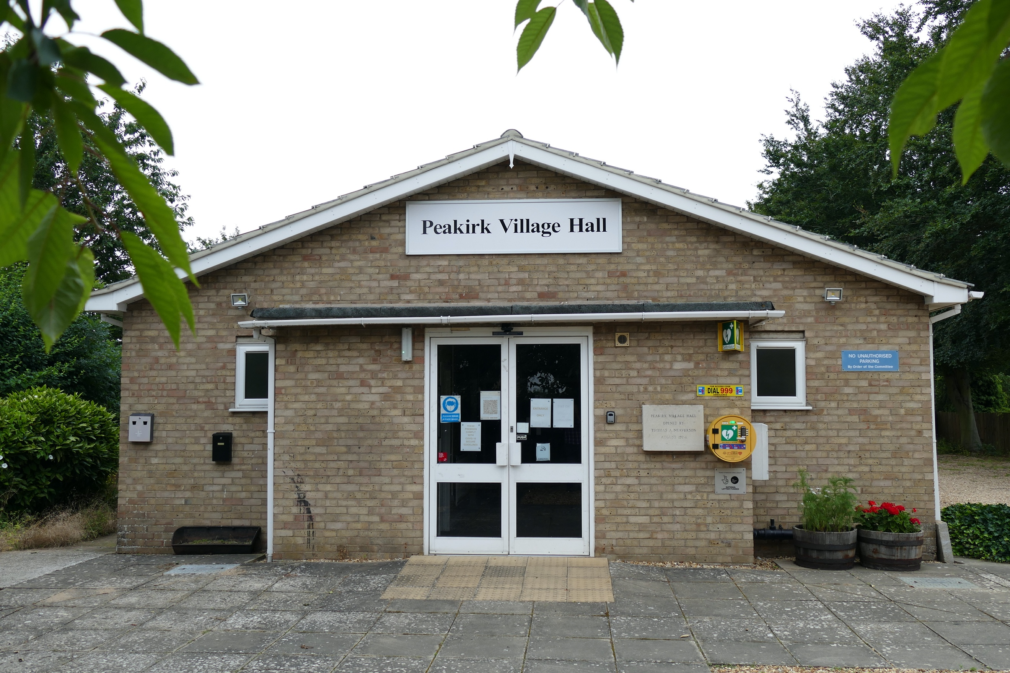
PEAKIRK VILLAGE HALL AGM
7.30 pm Tuesday 21st July 2026
In the village hall
DID YOU KNOW:
The hall is owned by the village and managed by residents.
Hire charges are reduced for residents & we now have an online booking request platform. Our bills are paid through bookings, and we receive no aid or concessions from elsewhere.
CURRENT ACTIVITIES
Yoga (Monday, Tuesday and Thursday) karmacorneryoga@yahoo.co.uk
Dog Training (Wednesday) wooflesdogtraining@gmail.com
Zumba (Thursday) zumbalicious@btinternet.com
Karate (Saturday) peterboroughdragons@gmail.com
Messy church First Sunday in the month 9bridgescommunications@gmail.com
Tuesday@10(coffee morning) Second Tuesday in the month.
Cheese & Wine / Refreshments will be served.
Please join us and see what happens in your Village Hall

Drama group, according to productions.
1940’s Dancers(Sunday afternoons)
Knitting Club
Pilates Class bode.pilatesandyoga@gmail.com
Smart Fitt Fitness Class (Friday)
Dog Scentwork
Peterborough Model Flying Club - once a month
(Friday Oct to Mar) blever@btinternet.com

Joining the committee
WHILST THE HALL IS OWNED BY THE VILLAGE, ITS MANAGEMENT RESTS WITH A VERY SMALL COMMITTEE OF JUST 8 TRUSTEES AND WE REQUIRE MORE COMMITTEE MEMBERS URGENTLY DUE TO SOME MEMBERS RETIRING THIS SUMMER.
We meet in the Village Hall approximately 4 times a year and discuss maintenance of the hall and bookings.
IF YOU WOULD LIKE TO BECOME A TRUSTEE AND JOIN THE COMMITTEE PLEASE DO COME ALONG TO THE MEETING OR CONTACT ANY HALL TRUSTEE

We look forward to seeing you on 21st July
David Hankins Chairman Peakirk Village Hall Committee David.hankins2009@btinternet.com
Debi Armitage – Secretary Peakirk Village Hall Committee
debi@debiarmitage.plus.com

